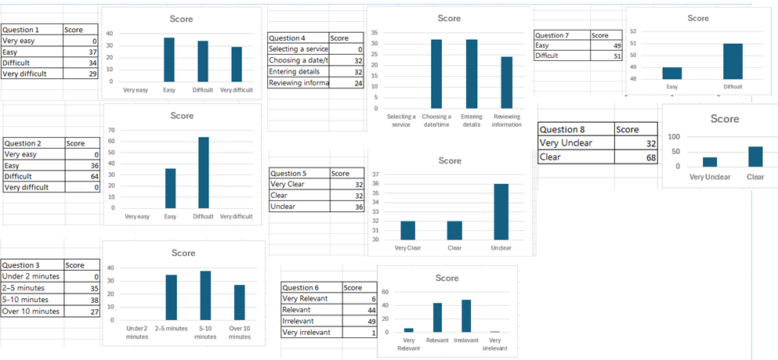
Feedback from 100 users shows that many people struggled with the booking system. Around half found it difficult to know where to start or to complete a booking due to bad and unclear navigation, confusing labels, badly explained forms. Others found the process easier once they got started, but still had small issues with calendars, entering information, and understanding privacy details.
While the system has positives such as clear confirmation screens, most problems happen at the start of the journey or when filling in forms. Users often said navigation should be clearer, buttons more visible, and instructions simpler. Improving these areas would make the booking process easier, reduce mistakes, and increase user confidence.

